NAND & NOR Gate
OBJECTIVE:
- To investigate the behavior of the NOR gate using IC & Transistor.
- To investigate the behavior of the NAND gate using IC & Transistor.

THEORY:
In Experiment 1, you learned the characteristics of three of the fundamental logic gates: the AND, OR, and NOT. You will now be introduced to two of the remaining logic gates: the NAND and NOR. The NAND and NOR gates are nothing more than inverted AND and OR gates, respectively. That is important, but not the most important thing. The fact that a NAND or a NOR can be used to create all other gates is important, because this fact has made them more popular in use than the others.
EQUIPMENT / REQUIREMENT:
- 7400 IC
- 7402 IC
- 4 NPN Transistor
- 4 LED or Logic probe
- 0-5 volt DC power supply

PROCEDURE:
Figure 2-1 shows logic symbols of NAND & NOR Figure 2-2 shows the layouts of NAND gate IC (7400) & NOR gate IC (7402). The pin configuration is also given in the layouts. Construct the circuit with the help of these layouts. Pin no. 7 and Pin no. 14 of each IC is Ground and VCC respectively. Apply different inputs on the given input pins and observe the out puts, and then complete the truth tables 2-1 and 2-2 of these gates.

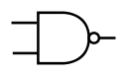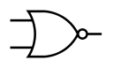
- NAND gate Symbol (b) NOR gate Symbol
Fig2-1

Internal Circuits of NAND, NOR Gate using Transistor
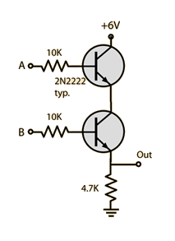
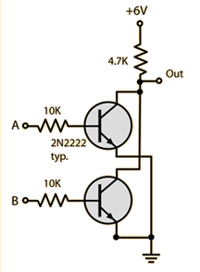

(a) NAND gate (b) NOR gate

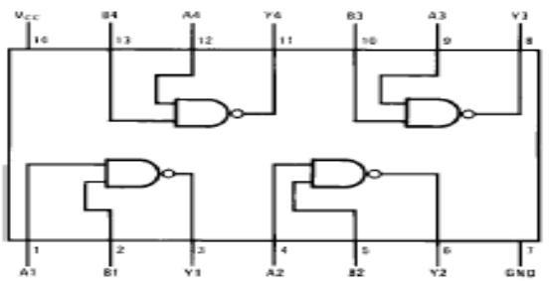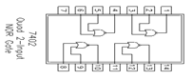
(a) IC configuration NAND 7400 gate (b) IC Configuration NOR 7402 gate

Fig 2-2

OBSERVATION TABLE:

A | B | Q=(A+B)’
0 | 0 | 1
0 | 1 | 0
1 | 0 | 0
1 | 1 | 0
Truth Table 2-1 for NOR gate

A | B | Q=(A*B)’
0 | 0 | 1
0 | 1 | 1
1 | 0 | 1
1 | 1 | 0
Truth Table 2-2 for NAND gate

QUESTIONS / RESULTS:

Why are NAND and NOR gates called universal gates?
A. NAND and NOR are called universal gates because all the other gates like
AND,OR,NOT,XOR and NOR can be derived from it.
- If the 0 and 1 were inputs for a NAND gate, what would be the output?
A. The output will be high.
- If a signal passing through a gate is inhibited by sending a LOW into one of the inputs, and the output is HIGH, the gate is an?
A. The gate will be NAND gate.
- When used with an IC, what does the term "QUAD" indicates?
A. Quad means that the IC has 4 circuits inside it which performs the same function.
- A High Voltage (5volt) stood for a TLL Gate.

Addition Task to be performed:
- Implement OR gate using NAND gate
A. OR gate can simply be implemented by using two NAND gates.
A | B | C | D | AB | CD | A'B' | C'D' | (A'B')+( C'D')
0 | 0 | 0 | 0 | 0 | 0 | 1 | 1 | 1
0 | 0 | 0 | 1 | 0 | 0 | 1 | 1 | 1
0 | 0 | 1 | 0 | 0 | 0 | 1 | 1 | 1
0 | 0 | 1 | 1 | 0 | 1 | 1 | 0 | 1
0 | 1 | 0 | 0 | 0 | 0 | 1 | 1 | 1
0 | 1 | 0 | 1 | 0 | 0 | 1 | 1 | 1
0 | 1 | 1 | 0 | 0 | 0 | 1 | 1 | 1
0 | 1 | 1 | 1 | 0 | 1 | 1 | 0 | 1
1 | 0 | 0 | 0 | 0 | 0 | 1 | 1 | 1
1 | 0 | 0 | 1 | 0 | 0 | 1 | 1 | 1
1 | 0 | 1 | 0 | 0 | 0 | 1 | 1 | 1
1 | 0 | 1 | 1 | 0 | 1 | 1 | 0 | 1
1 | 1 | 0 | 0 | 1 | 0 | 0 | 1 | 1
1 | 1 | 0 | 1 | 1 | 0 | 0 | 1 | 1
1 | 1 | 1 | 0 | 1 | 0 | 0 | 1 | 1
1 | 1 | 1 | 1 | 1 | 1 | 0 | 0 | 0
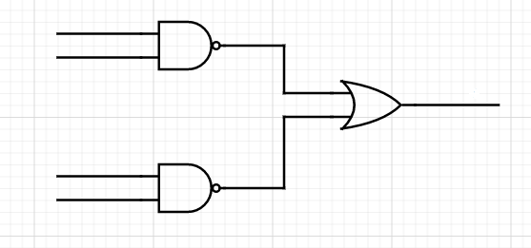
A

B

C

D

- Implement AND, OR gate using NOR gate
A(1). OR gate can simply be implemented by using two NOR gates.
A | B | C | D | A+B | C+D | (A+B)' | (C+D)' | (A+B )' + (C+D) '
0 | 0 | 0 | 0 | 0 | 0 | 1 | 1 | 1
0 | 0 | 0 | 1 | 0 | 1 | 1 | 0 | 1
0 | 0 | 1 | 0 | 0 | 1 | 1 | 0 | 1
0 | 0 | 1 | 1 | 0 | 1 | 1 | 0 | 1
0 | 1 | 0 | 0 | 1 | 0 | 0 | 1 | 1
0 | 1 | 0 | 1 | 1 | 1 | 0 | 0 | 0
0 | 1 | 1 | 0 | 1 | 1 | 0 | 0 | 0
0 | 1 | 1 | 1 | 1 | 1 | 0 | 0 | 0
1 | 0 | 0 | 0 | 1 | 0 | 0 | 1 | 1
1 | 0 | 0 | 1 | 1 | 1 | 0 | 0 | 0
1 | 0 | 1 | 0 | 1 | 1 | 0 | 0 | 0
1 | 0 | 1 | 1 | 1 | 1 | 0 | 0 | 0
1 | 1 | 0 | 0 | 1 | 0 | 0 | 1 | 1
1 | 1 | 0 | 1 | 1 | 1 | 0 | 0 | 0
1 | 1 | 1 | 0 | 1 | 1 | 0 | 0 | 0
1 | 1 | 1 | 1 | 1 | 1 | 0 | 0 | 0
(A+B )' + (C+D) '
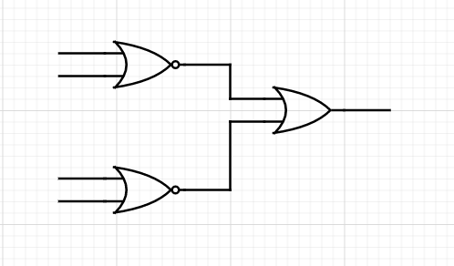
A
B

C

D
A(2). AND gate can simply be implemented by using two NOR gates.
(A+B )' . (C+D) '
A | B | C | D | A+B | C+D | (A+B)' | (C+D)' | (A+B )' . (C+D) '
0 | 0 | 0 | 0 | 0 | 0 | 1 | 1 | 1
0 | 0 | 0 | 1 | 0 | 1 | 1 | 0 | 0
0 | 0 | 1 | 0 | 0 | 1 | 1 | 0 | 0
0 | 0 | 1 | 1 | 0 | 1 | 1 | 0 | 0
0 | 1 | 0 | 0 | 1 | 0 | 0 | 1 | 0
0 | 1 | 0 | 1 | 1 | 1 | 0 | 0 | 0
0 | 1 | 1 | 0 | 1 | 1 | 0 | 0 | 0
0 | 1 | 1 | 1 | 1 | 1 | 0 | 0 | 0
1 | 0 | 0 | 0 | 1 | 0 | 0 | 1 | 0
1 | 0 | 0 | 1 | 1 | 1 | 0 | 0 | 0
1 | 0 | 1 | 0 | 1 | 1 | 0 | 0 | 0
1 | 0 | 1 | 1 | 1 | 1 | 0 | 0 | 0
1 | 1 | 0 | 0 | 1 | 0 | 0 | 1 | 0
1 | 1 | 0 | 1 | 1 | 1 | 0 | 0 | 0
1 | 1 | 1 | 0 | 1 | 1 | 0 | 0 | 0
1 | 1 | 1 | 1 | 1 | 1 | 0 | 0 | 0
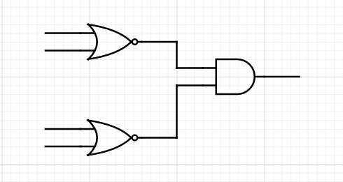

CONCLUSION:
NAND and NOR are two universal gates, they are called universal gates because other logical gates can be derived from it.
NAND(The output of a NAND gate is true when one or more, but not all, of its inputs are false. If all of a NAND gate's inputs are true, then the output of the NAND gate is false)
NOR(Its output is "true" if both inputs are "false." Otherwise, the output is "false.")

